I Islám na postupu světem

What is the difference between Sunni and Shia Muslims?
The Economist: May 28th 2013, 23:50 by S.B.
CLASHES between Islam's two big sects, the Sunni and the Shia, take place across the Muslim world. In the Middle East a potent mix of religion and politics has sharpened the divide between Iran’s Shia government and the Gulf states, which have Sunni governments. Last year a report by the Pew Research Centre, a think tank, found 40% of Sunnis do not consider Shia to be proper Muslims. So what exactly divides Sunni and Shia Islam and how deep does the rift go?
The argument dates back to the death in 632 of Islam’s founder, the Prophet Muhammad. Tribal Arabs who followed him were split over who should inherit what was both a political and a religious office. The majority, who would go on to become known as the Sunnis, and today make up 80% of Muslims, backed Abu Bakr, a friend of the Prophet and father of his wife Aisha. Others thought Muhammad’s kin the rightful successors. They claimed the Prophet had anointed Ali, his cousin and son-in-law—they became known as the Shia, a contraction of "shiaat Ali", the partisans of Ali. Abu Bakr’s backers won out, though Ali did briefly rule as the fourth caliph, the title given to Muhammad’s successors. Islam's split was cemented when Ali’s son Hussein was killed in 680 in Karbala (modern Iraq) by the ruling Sunni caliph’s troops. Sunni rulers continued to monopolise political power, while the Shia lived in the shadow of the state, looking instead to their imams, the first twelve of whom were descended directly from Ali, for guidance. As time went on the religious beliefs of the two groups started to diverge.
Today the world’s 1.6 billion Muslims all agree that Allah is the only God and Muhammad his messenger. They follow five ritualistic pillars of Islam, including Ramadan, the month of fasting, and share a holy book, the Koran. But while Sunnis rely heavily on the practice of the Prophet and his teachings (the “sunna”), the Shia see their ayatollahs as reflections of God on earth. This has led Sunnis to accuse Shia of heresy, while Shia point out that Sunni dogmatism has led to extremist sects such as the puritanical Wahhabis. Most Shia sects place importance on the belief that the twelfth and final imam is hidden (called "in occultation") and will reappear one day to fulfill divine will. Meanwhile, their sense of marginalisation and oppression has led to mourning ceremonies such as ashura, when followers flagellate themselves to commemorate Hussein’s death at Karbala.

There has never been a clash between the Shia and Sunni on the scale of the Thirty Years War, which saw Christian sects fight each other in 17th-century Europe with great loss of life. This is partly because the Shias, ever mindful of their minority status, retreated. The lines that divide Muslims in the Middle East today are being drawn by politics as much as by religion. The "Shia Crescent" that runs from Iran, through Mr Assad’s regime in Damascus to Hizbullah in Lebanon was once praised by Sunni figures. But the revolutions in the region have pitted Shia governments against Sunni Gulf states such as Saudi Arabia and Qatar, who have supported their co-religionists with cash. This is strengthening Sunni assertiveness and making the Shia feel more threatened than usual. In most cases, though, members of the two sects still live harmoniously together.

Islam is growing. But ageing and slowing. That will change the world
The Economist: Jan 27th 2011
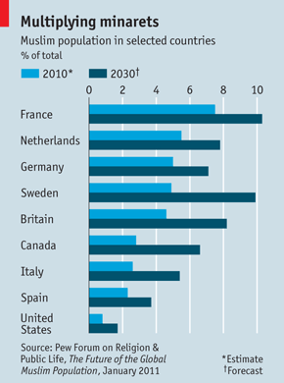
ARE Muslims taking over the world, or at a minimum, transforming Europe into Eurabia? Whatever your hopes or fears for the future of the world's religions, a report published this week has plenty to stoke them. “The Future of the Global Muslim Population”, produced by the Pew Research Centre, a non-profit outfit based in Washington, DC, reckons Muslim numbers will soar from 1.6 billion in 2010 to 2.2 billion by 2030. In other words, from 23.4% to 26.4% of the global total.
At the heart of its analysis is the ongoing effect of a “youth bulge” which peaked in 2000. In 1990 Islam's share of the world's youth was 20%; in 2010, 26%. In 2030 it will be 29% (of 15-to-29-year-olds). But the Muslim world is slowly heading towards paunchiness: the median age in Muslim-majority countries was 19 in 1990. It is 24 now, and will be 30 by 2030. (For French, Germans and Japanese the figure is 40 or over.) This suggests Muslim numbers will ultimately stop climbing, but later than the rest of the world population.
The authors call their calculations demographic, not political. Drawing on earlier Pew research, they say conversion is not a big factor in the global contest between Islam, Christianity and other faiths; the converts balance out. Nor do they assess piety; via the imperfect data of the United Nations, the European Union and national statistics, they aim simply to measure how many people call themselves Muslim, at least culturally, if asked.
New numbers, they say, will change the world map. As Indonesia prospers, its birth rate is falling; South Asia's remains very high. By 2030, 80m extra mouths in Pakistan will boost its Muslim numbers to 256m, ousting Indonesia (with 239m) as the most populous Islamic land. India's Muslim minority will be nearly as large at 236m—though growth is slowing there too. And in 2030 India's Muslims will still constitute only a modest 15.9% of that country's swelling total, against 14.6% now.
The report asserts no causal link between Islamic teaching and high fertility rates, although it notes that poverty and poor education are a problem in many Muslim lands. In Muslim countries such as Bangladesh and Turkey, it observes, the lay and religious authorities encourage birth control. Better medical care and lower mortality boost poor-country population numbers too.
Some bleak findings concern Nigeria, where Muslim numbers are seen rising to 117m in 2030 from 76m now, edging up from 47.9% to 51.5% of the population. Illiteracy among Nigerian women of child-bearing age is three times as high among Muslims (71.9%) as among others (23.9%). Two-thirds of Nigerian Muslim women lack any formal education; that goes for just over a tenth of their non-Muslim sisters. The fertility rate is between six and seven children per Muslim woman, versus five for non-Muslims. It is hard to prove that these factors are related, but they do seem to form a pattern.
Eurabian nights
The total Muslim share of Europe's population is predicted to grow from 6% now to 8% in 2030: hardly the stuff of nightmares. But amid that are some sharp rises. The report assumes Britain has 2.9m Muslims now (far higher than the usual estimates, which suggest 2.4m at most), rising to 5.6m by 2030. As poor migrants start families in Spain and Italy, numbers there will rocket; in France and Germany, where some Muslims are middle-class, rises will be more modest—though from a higher base. Russia's Muslims will increase to 14.4% or 18.6m, up from 11.7% now (partly because non-Muslims are declining). The report takes a cautious baseline of 2.6m American Muslims in 2010, but predicts the number will surge by 2030 to 6.2m, or 1.7% of the population—about the same size as Jews or Episcopalians. In Canada the Muslim share will surge from 2.8% to 6.6%.
How will liberal democracies accommodate such variety? The clarity of a written constitution may give America an advantage over many European countries, where unwritten custom has more sway. Jonathan Laurence, an Islam-watcher and professor at Boston College, thinks Europe could rise to the challenge, but failure is also easy to imagine. Europe's Muslims should, by 2030, have become articulate and effective political bargainers. But with nativism on the march, it is also highly possible that Muslims will come to feel they have less in common with their fellow citizens than with their growing band of co-religionists elsewhere.

Sharia do like it
The Economist: Apr 30th 2013, 16:12
A new study reveals what Islam means in different countries
ISLAMIC law, in many eyes, has overtones of rigid puritanism. Yet some of its staunchest backers are also strong supporters of religious pluralism, reports the Pew Research Centre, a think-tank, in a survey of 38,000 Muslims conducted in 39 countries. In Morocco 78% of respondents think that non-Muslims are very free to practice their faith there, and 79% of those think this is “a good thing”. Yet 83% want sharia enshrined in law. A majority of Thais (77%) and Pakistanis (84%) yearn for Islamic law too. But most also say that other religions are very free to worship (79% and 75% respectively)—and they agree that this is, overwhelmingly, “a good thing”. Religious freedom, however, is a slippery term, with implications for individuals and for the collective practice of faith. Muslims in some countries both strongly approve of religious freedom—and support the death penalty for apostates from Islam. Three-quarters of Pakistanis who favour sharia do. Views vary over how sharia should be applied. Tunisian backers, though keen on religious judges (62%), have far less appetite for executing apostates (29%). And those countries where most support sharia are not always its strictest followers. Though around three-quarters endorse it in both Indonesia and Egypt, less than half of those Indonesians support stoning for adultery; in Egypt, 81% do. Yet 74% of Egyptians who favour sharia also think it should apply to non-Muslims, the highest proportion among polled countries.
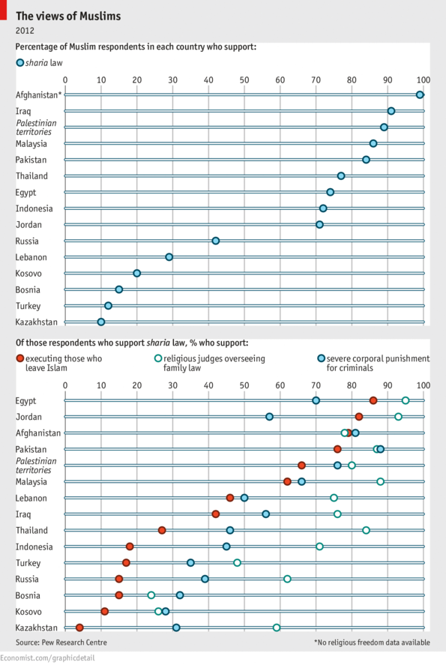

Alcohol in the Muslim world
The Economist: Aug 17th 2012, 13:41
NOBODY knows exactly when Islamic scholars decided that booze was sinful. In the 1970s political Islam led some countries such as Iran and Pakistan to ban alcohol, although many do not and exceptions are made for non-Muslims. In some countries the punishment for Muslims caught quaffing are severe: 80 lashes in the case of Iran. Things may get more arid yet as Islamist parties from Indonesia to Tunisia moot restrictions on alcohol. The number of drinkers varies by country, but some put the total at 5% of those identifying themselves as Muslim. Drinking may even be on the rise. Between 2001 and 2011 sales of alcohol in the Middle East, where Muslims dominate, grew by 72%, against a global average of 30%. That rise is unlikely to be accounted for by non-Muslims and foreigners alone. The black market for spirits flourishes in Libya, while Iranians are adept at producing home brew. Could Islam become more tolerant of drinking? A handful of scholars permit alcohol as long as it is not made from grapes and dates, because these are specifically mentioned in the Koran.
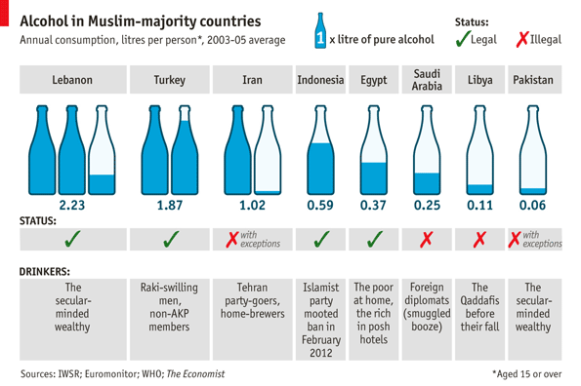

Though conflict between God’s law and man’s continues to puzzle the Islamic world, Muslim thinkers have been imaginative in seeking reasonable compromise
The Economist: Aug 6th 2011
THE statistics do not look very encouraging. Of the 50-plus countries where Muslims are in the majority, only two (Indonesia and Mali) enjoy political liberty as defined by Freedom House, a New York-based monitor of human rights and democracy. The Democracy Index, run by the Economist Intelligence Unit, adds Malaysia to that shortlist, rating the three countries as “flawed democracies”; other Muslim lands are put in a lower category.
With every year that has passed since al-Qaeda's attacks on America in September 2001, it has become more fashionable to argue that something about Islam makes it hard to reconcile with full-blown liberal democracy—in the sense of a political system where all citizens have an equal right to vote, and are equal in other basic ways. And with equal vehemence, Muslims have retorted: there is nothing in their faith which precludes a liberal democracy, and much which works in its favour.
For the Islamosceptics, there are several lines of argument. First of all, they say, devout Muslims will always, in their hearts, see a global caliphate—a seat of religious-cum-political authority, holding sway over the whole Islamic world—as the ideal form of governance. If that is the case, liberal democracy, in which authority flows from the people regardless of faith, will always be regarded as a compromise at most.
It is true that the dream of a caliphate is held dear by several categories of Muslim. They include followers of al-Qaeda, bent on war with the “Jews and crusaders” of the Western world; many supporters of the Muslim Brotherhood, who believe in active participation in politics but still see Islamic governance as a long-term goal; and Hizb ut-Tahrir (Party of Liberation) which, in places that range from British universities to Uzbek slums, propagates the idea that secular elections are sacrilege.
But is the caliphate a religious doctrine—something central to Islam—or just a detail, however important, of history? In all readings of Islam, especially the ones that now dominate in the Middle East, there is huge reverence for the first four caliphs who succeeded Muhammad as leaders of the emerging Muslim community. All subsequent Muslim empires had caliphs and the abolition of the last caliphate—by Turkey's new rulers in 1924—sent shock waves through the world of Islam.
But as Mustafa Akyol, a Turkish writer, notes in a new book, “Islam Without Extremes”, the appointment of the first four caliphs is ultimately seen—at least in Sunni Islam—as a political decision, albeit a very wise one, and not a theological one. Though Mr Akyol empathises with global Islam's dismay over the caliphate's abolition 13 centuries later, that too, he says, is a political matter, not a theological one. Even in Shia Islam, where succession to Muhammad is seen as a sacred mandate, the authority handed down was spiritual, not temporal; in that sense the power now held by Iran's clergy is an anomaly.
A second line of argument about Islam and democracy concerns law. More than most other religions, the founding texts of Islam include very specific injunctions about crime, punishment and family law. By modern standards these commands are anything but liberal. The Koran mandates flogging for unlawful sex, and a strongly held tradition ascribes to Muhammad the view that adulterers should be stoned to death. Over inheritance, the Koran is also specific—a daughter is entitled to have half as much as a son—and the various legal schools of Islam are even more so, setting out with absolute precision the entitlement of each distant relative.
In most understandings of liberal democracy, penal and civil codes are a matter for the people's freely elected representatives to decide, within the confines of a humanly drafted constitution. How can that possibly be reconciled with the notion that such questions have been settled for ever by divine revelation?
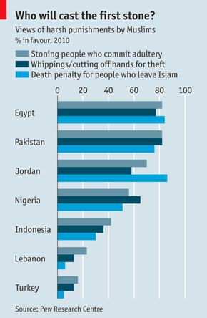
Contemporary Muslims acknowledge that the issue is a tricky one. If the Koran is a revelation of God, then its prescriptions cannot simply be dismissed as irrelevant or outdated. Some believers (see chart) would still like to apply Islamic penalties to the letter. But a distinction can be made between commands that were given in a certain context, and those which hold good for all time. And modern Muslims, including rather conservative ones, have been quite imaginative in rereading some of Islam's legal and penal traditions.
Tariq Ramadan, an influential figure among Western Muslims, has suggested that it may sometimes be right for families to opt out of Koranic rules on inheritance—unless men are prepared to shoulder all the obligations that go with their privileged rights. Maulana Maudoodi, the father of Pakistani Islamism, said amputation should not be practised on those who are driven to steal by poverty or famine; in other words, a just society was more important than harsh punishment.
Beyond the legal details, some still see a deeper problem, concerning the very nature of political authority, and the ability of different ideas on this subject to coexist. John Rawls, an American theorist of liberal democracy, showed how people who differ over metaphysics—say Catholics and atheists—can coexist politically on the basis of a deep compromise, on certain conditions. They must believe in reason, and see the political system as reasonable in their own terms.
Mohammad Fadel, an Egyptian-born political scientist at the University of Toronto, has argued that Islam—even in conservative readings—can find a happy place in a Rawls-style democracy. In medieval times, he recalls, Islamic thought divided between the Mutazilites, who stressed human reason, and the ultimately victorious Asharites who thought that God alone could adjudicate right and wrong. But even within the latter school, there is some place for human reason—enough to make it possible for conservative Muslims to live quite comfortably in a Rawlsian world.
That will only happen if Muslims want it to and see an interest in doing so. Will they? Vali Nasr, an American political scientist, thinks Western Islam-watchers put too much stress on philosophy and not enough on social and economic factors. In his view, wherever the middle class is strong (as in Turkey), it will re-emphasise the moral rules of Islam—over honest trading, say—and downgrade Islam's real or imagined prescriptions for politics and law. In many Muslim countries that moment still seems a long way off.

Ex-Muslim atheists are becoming more outspoken, but tolerance is still rare
The Economist: Nov 24th 2012 | BEIRUT
A MOB attacked Alexander Aan even before an Indonesian court in June jailed him for two and a half years for “inciting religious hatred”. His crime was to write “God does not exist” on a Facebook group he had founded for atheists in Minang, a province of the world’s most populous Muslim nation. Like most non-believers in Islamic regions, he was brought up as a Muslim. And like many who profess godlessness openly, he has been punished.
In a handful of majority-Muslim countries atheists can live safely, if quietly; Turkey is one example, Lebanon another. None makes atheism a specific crime. But none gives atheists legal protection or recognition. Indonesia, for example, demands that people declare themselves as one of six religions; atheism and agnosticism do not count. Egypt’s draft constitution makes room for only three faiths: Christianity, Judaism and Islam.
Sharia law, which covers only Muslims unless incorporated into national law, assumes people are born into their parents’ religion. Thus ex-Muslim atheists are guilty of apostasy—a hudud crime against God, like adultery and drinking alcohol. Potential sanctions can be severe: eight states, including Iran, Saudi Arabia, Mauritania and Sudan have the death penalty on their statute books for such offences.
In reality such punishments are rarely meted out. Most atheists are prosecuted for blasphemy or for inciting hatred. (Atheists born to non-Muslim families are not considered apostates, but they can still be prosecuted for other crimes against religion.) Even in places where laws are lenient, religious authorities and social attitudes can be harsh, with vigilantes inflicting beatings or beheadings.
Many, like Kacem el-Ghazzali, a Moroccan, reckon the only solution is to escape abroad. The 23-year-old was granted asylum in Switzerland after people found out he was the author of an anonymous blog, Atheistica.com. Even in non-Muslim lands ex-believers are scared of being open, says Nahla Mahmoud, a 25-year-old Sudanese atheist who fled to Britain in 2010. “Muslim communities here don’t feel comfortable with having an ex-Muslim around,” she says, noting that extremists living in the West may harass non-believers there too.
Facebook groups for atheists, mostly pseudonymous, exist in almost every Muslim country. Social media give non-believers more clout—but also make them more conspicuous, and therefore vulnerable. But the real blame lies with religious intolerance. In the 1950s and 1960s secularism and tolerance prevailed in many majority-Muslim countries; today religion pervades public and political life. Sami Zubaida, a scholar at London’s Birkbeck College, speaks of increasing polarisation, with “growing religiosity at one end of the spectrum and growing atheism and secularism at the other.”
The rise to power of Islamist parties after the Arab revolutions is likely to make life more miserable still for those who leave Islam. New rulers in Tunisia and Egypt have jailed several young people who have been outspoken about their lack of belief. Such cases occurred before the revolutions, but seem to have become more common. Alber Saber Ayad, an Egyptian Christian activist who ran a Facebook page for atheists, has been in custody since September for “insulting religion”. His alleged offence was posting a link to an infamous YouTube video that caused protests in the Islamic world that month. He was arrested by a Christian policeman: Egypt’s Coptic church does not look kindly on atheism either.
Good news?
The Arab upheavals and the growing number of open non-believers have sparked some debate. In Egypt, Bassem Youssef, a doctor-cum-comedian, has bravely called for discussion rather than hostility. Islam co-existed with pagans and atheists at the height of its power, he writes. Some of the finest medieval Arabic and Persian poets and grammarians were atheists (though several were also famously executed).
Young activists, albeit often exiled, such as Mr Ghazzali, have become more vociferous about their right not to believe in a God. Organisations abroad for former Muslims are increasingly active, too. The Council of Ex-Muslims of Britain, set up by a group of non-believers five years ago, provides refuge for those who have renounced Islam and tries to “break the taboo” about apostasy.
In a move hailed by campaigners, Kuwait’s emir in June blocked a bill to make apostasy a capital offence. Yet seeking secular laws or social tolerance ignores the root of the problem, says Ibn Warraq, the pseudonymous Indian-born author of “Leaving Islam”, a collection of essays by ex-believers, and other books. He lives in exile and has received death threats for campaigning on the behalf of apostates. The prevailing interpretation of Islam, he says, simply cannot tolerate Muslim unbelievers. Arguments for the death penalty are usually based on a Hadith, one of the sayings which, along with the Koran, form the basis of Islamic law: “The Prophet said: whoever discards his religion, kill him.”
Yet other texts have a different message. The Koran’s notably tolerant Sura 109 includes words such as “For you is your religion, and for me is my religion.” Moderates also note that though the Koran says blasphemers will not be forgiven, it does not mention the death penalty. Some argue that in Islam’s early years apostasy was akin to treason, earning harsh penalties that are no longer acceptable.
Although some Islamic theologians interpret these provisions to mean that apostates will be punished in the afterlife, most see them as ordering that former Muslims must be punished by death. All four schools of Sunni Islamic law teach that male apostates should be put to death, though two say that female renegades should only be imprisoned. A number of leading Islamic figures, such as Egypt’s grand mufti and Yusuf al-Qaradawi, a Qatar-based preacher, say that the death penalty is deserved if the apostate “subverts society” or “damages Islam”. All agree, however, that repentant apostates should be spared; the time and sincerity needed for such disavowals to count is debated.
Ibn Warraq says that the nub of the problem is that sharia makes atheism the number one sin, ahead of murder. A theological debate on atheism has yet to begin. Public opinion, though variable, tends to the censorious. A 2010 survey by the Pew Research Centre, an American think-tank, found that 84% of Muslims in Egypt and 86% in Jordan backed the death penalty for apostates, compared with 51% in Nigeria and 30% in Indonesia.
Such attitudes may stoke atheist sentiment even as they deter its expression. Ms Mahmoud recalls how her primary school teacher punished her in art class for sketching a picture of Allah, which is forbidden in Islam. With fewer rights than her male peers and annoyed by a ban on studying evolution, she felt pushed away: “These incidents made me gradually refuse Islam until I completely renounced it and became an atheist.”

A debate about homosexuality in Islam is beginning. But in Muslim lands persecution—and hypocrisy—are still rife
The Economist: Feb 4th 2012
ONE leaflet showed a wooden doll hanging from a noose and suggested burning or stoning homosexuals. “God Abhors You” read another. A third warned gays: “Turn or Burn”. Three Muslim men who handed out the leaflets in the English city of Derby were convicted of hate crimes on January 20th. One of them, Kabir Ahmed, said his Muslim duty was “to give the message”.
That message—at least in the eyes of religious purists— is uncompromising condemnation. Of the seven countries that impose the death penalty for homosexuality, all are Muslim. Even when gays do not face execution, persecution is endemic. In 2010 a Saudi man was sentenced to 500 lashes and five years in jail for having sex with another man. In February last year, police in Bahrain arrested scores of men, mostly other Gulf nationals, at a “gay party”. Iranian gay men are typically tried on other trumped-up charges. But in September last year three were executed specifically for homosexuality. (Lesbians in Muslim countries tend to have an easier time: in Iran they are sentenced to death only on the fourth conviction.)
Gay life in the open in Muslim-majority countries is rare, but the closet is spacious. Countries with fierce laws, such as Saudi Arabia, also have flourishing gay scenes at all levels of society. Syria's otherwise fearsome police rarely arrest gays. Sibkeh park in Damascus is a tree-filled children's playground during the day. By night it is known for the young men who linger on its benches or walls. Wealthy Afghans buy bachabazi, (dancing boys) as catamites.
Where laws are gentler, authorities find other ways to crack down. In the Jordanian capital, Amman, several gay hangouts have been raided or closed on bogus charges, such as serving alcohol illegally. Even where homosexuality is legal (as in Turkey), official censure can be fierce. A former minister for women's affairs, Aliye Kavaf, called it “a disease”; the interior minister, Idris Naim Sahin, cited it (along with Zoroastrianism and eating pork) as an example of “dishonour, immorality and inhuman situations”. A new film, “Zenne Dancer”, portrays a young man's murder in 2008 as Turkey's first gay “honour killing” (the suspect, the victim's father, is on the run).
Charges of homosexuality can also be used in political repression. The Malaysian opposition leader, Anwar Ibrahim, was twice tried for sodomy; the attorney-general is appealing against the latest acquittal. Intolerance can unite otherwise warring factions. In Nigeria Muslims and conservative Christians alike back a proposed law banning gay marriage (and indirectly criminalising all same-sex unions).
The democratic upheavals of the Arab spring have brought little comfort. Hossein Alizadeh of the International Gay and Lesbian Human Rights Commission, a New York-based lobby group, says that religious awakening is strengthening hardline interpretations of Islam and a repressive backlash on all kinds of sex-related issues. But the laws left behind by the former regimes in countries such as Tunisia and Egypt seem draconian enough to satisfy the new governments.
An ominous counter-example is Iraq. The previous Iraqi regime was politically repressive but unbothered by sexual mores. Now men even suspected of being gay face kidnappings, rape, torture and extrajudicial killing. Ali Hili, head of a group called Iraqi LGBT, (Lesbian, Gay, Bisexual and Transgender) says that since the 2003 invasion more than 700 people have been killed because of their sexuality. It is the most dangerous place in the world for sexual minorities, he says.
Theology or technology
One small source of hope is the internet: life online offers gays safety, secrecy and the chance to make their case. In a campaign called “We are everywhere” Iranian gays and lesbians are posting protest videos on Facebook. In one, entitled “Ali the Queer”, a man speaks of his longing for a world in which those who deviate from the heterosexual standard are no longer considered unnatural or abnormal. However, a video newly posted from the United Arab Emirates shows an effeminate gay man being “cured” by two straight men.
The internet also offers a chance to debate the fundamental issue: the Islamic prohibition of homosexuality. This is based on a tale (common to all three Abrahamic religions, though details differ) of a man called Lot and the cities of Sodom and Gomorrah. These were engulfed in fire and brimstone as divine punishment for the local penchant for gay sex.
Earlier Islamic societies were less hardline. An 11th-century Persian ruler advised his son to alternate his partners seasonally: young men in the summer and women in the winter. Many of the love poems of the eighth-century Abu Nuwas in Baghdad, and of other Persian and Urdu poets, were addressed to boys. In medieval mystic writings, particularly Sufi texts, it is unclear whether the beloved being addressed is a teenage boy or God, providing a quasi-religious sanction for relationships between men and boys. Austere European chroniclers fumed at the indulgent attitudes to gay sex in the Caliphs' courts (now the censure is the other way).
Like liberal Jewish and Christian scholars in recent decades, some Muslim thinkers are now finding theological latitude. “The Koran does not condemn homosexuality,” says Scott Siraj al-Haqq Kugle, an American Muslim convert who teaches Islamic studies at Emory University in Atlanta. The story of Lot, he argues, deals with male rape and violence, not homosexuality in general. Classical Islamic theologians and jurists were mostly concerned with stifling lustful immorality, he says. Koranic verses describe without condemnation men who have no sexual desire for women.
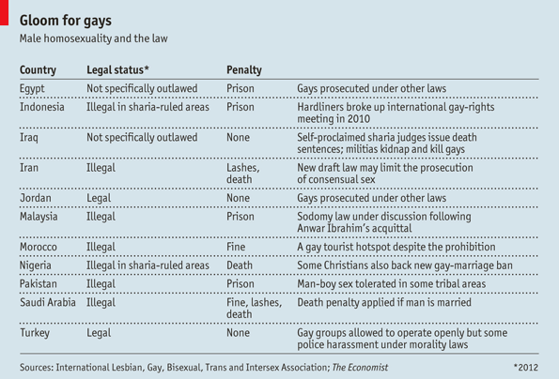
Arash Naraghi, an Iranian academic at Moravian College in Pennsylvania, suggests that the verses decrying homosexuality, like those referring to slavery and Ptolemaic cosmology, stem from common beliefs at the time of writing, and should be re-examined. Even Sheikh Muhammad Hussein Fadlallah, the late spiritual leader of Lebanon's Hizbullah party-cum-militia, conceded that more research is needed in order to understand homosexuality.
Unsurprisingly, the debate, such as it is, is led by gay Muslims outside the Islamic world. Though their rights are better protected, they too can suffer from intolerance—as the trial in Derby last month highlighted. In European cities with lots of poor, pious Muslim immigrants, municipal politics brings some rum alliances. Ken Livingstone, a left-wing London politician with a strong record on gay rights, has in the past welcomed Yusuf al-Qaradawi, an America-bashing Muslim cleric from Egypt who supports the death penalty for homosexuality.
In Muslim countries activists have mostly shied away from the pitfalls of theological debate. Instead, groups such as Helem, a Lebanese NGO, use the secular language of human rights, citing United Nations declarations. Mr Alizadeh sees progress, though it is slow. Even some Muslim clerics, the group most resistant to reform, are shifting slightly. After attacks on gay men in Iraq in 2009, Muqtada al-Sadr, a fiery Shia cleric, condemned the killings. He said that the “depravity” of homosexuality should indeed be eradicated, but through “preaching and guidance” rather than violence. Optimists would see that as progress, of a sort.

Why Muslims fare better in America than in Europe
The Economist: Sep 6th 2014 DETROIT
THE State Department estimates that up to 100 American jihadists are fighting in Iraq and Syria. A video appearing to show a second American journalist being beheaded by the Islamic State is circulating. You might think this would be a difficult time to hold the annual conference of America’s largest Muslim organisation.
Yet the Islamic Society of North America’s gathering, which took place in Detroit over the Labour Day weekend, served as a reminder of how well America is assimilating a religious minority that has often struggled to feel at home in Europe. The conference hall was filled with Muslims of different races wearing clothes that identified them with different traditions. The Islamic Boy Scouts had a stand, as did a Muslim liberal-arts college from California. People discussed how to erect mosques without infringing America’s arcane building regulations, or swapped business cards in the food court. The star turn was a Southern Baptist, Jimmy Carter (whose grandson is in the news, too: see page 42). The only overt hostility to Israel came from two Hasidic Jews in fur shtreimel hats, who had come from Brooklyn to announce their solidarity with the people of Gaza.
America’s Muslims differ from Europe’s in both quantity and origin. The census does not ask about faith, but estimates put the number of Muslims in the country at around 1% of the population, compared with 4.5% in Britain and 5% in Germany. Moreover, American Islam is not dominated by a single sect or ethnicity. When the Pew Research Centre last tried to count, in 2011, it found Muslims from 77 countries in America. Most western European countries, by contrast, have one or two dominant groups—Algerians in France, Moroccans and Turks in Holland. This matters because the jumble of groups in America makes it harder for Muslim immigrants and their descendants to lead a life apart. Different traditions get squashed together. When building mosques, says Chris McCoy, a Kentucky native who is a prolific architect of Islamic buildings, “the question is usually not whether we should have an Indian- or a Saudi-style dome but, can we afford a dome?” Mixing breeds tolerance: Pew found that most American Muslims think that their faith is open to multiple interpretations, making them the Episcopalians of the Islamic world.
America’s Muslims are better off than their European co-religionists. They are almost as likely as other Americans to report a household income of $100,000 or more. The same cannot be said of the Pakistanis who came to work in the now-defunct textile mills of northern England or the Turks who became guest workers in West Germany. Many American Muslims arrived in the 1970s to complete their higher education and ended up staying. Muzammil Siddiqi, chairman of the Fiqh Council of North America, which issues fatwas, or religious opinions, to guide the behaviour of the country’s Muslims, is typical: he was born in India and holds a Harvard PhD in comparative religion.
There is a stark contrast between this group and some of the more recent immigrants from Somalia, who have fewer qualifications and lower wages (as do African-American Muslims, who make up about an eighth of the total). This divide, if anything, makes America’s Muslims look more like the nation as a whole.
On various measures of integration, Muslims score fairly well (see chart). A Pew study from 2011 found that 15% of Muslims who are married or living with someone have a spouse of a different faith. This may sound low, but it is higher than the intermarriage rate for American Jews at a comparable moment in their history, and above that of modern Mormons. According to the Pentagon, there were 3,600 Muslims on active duty in the armed forces in January 2012, the most recent date for which numbers are available. This reflects a plan to recruit Muslims to fight in Islamic countries where an ability to speak Arabic or Pashto is helpful.
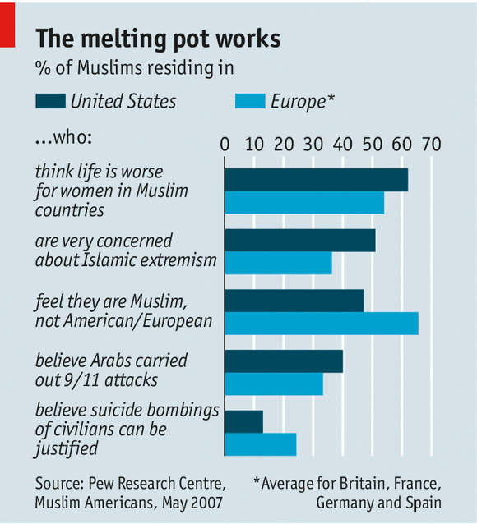
Alas, one or two American Muslims fight for the other side. In 2009 Nidal Hasan, a US army psychiatrist, shot and killed 13 people on a military base in Texas. He was encouraged by Anwar al-Awlaki, an American propagandist for al-Qaeda, who was himself killed in a drone strike in Yemen in 2011. The State Department says that the government has increased the scrutiny of travel plans made by people who have expressed sympathy with foreign Islamists, and will monitor Muslims returning from Iraq and Syria.
But this is hard. Douglas McCain, a 33-year-old African-American who converted to Islam in 2004 and was killed in August while fighting in Syria, travelled to the war zone via Turkey—an unremarkable place to go on holiday. Moner Abusalha, who drove a truck bomb into a restaurant in Syria in May, went to Jordan, returned to Florida and then set off on his suicide mission. In both cases relatives and friends were baffled by what the two men did. Nor is it clear that there were grounds for preventing either from travelling abroad.
For the past dozen years the FBI and other agencies have been watching mosques in the hope of spotting would-be terrorists early. This has yielded little, although the FBI did reveal one alarming conspiracy in 2009, when four men were convicted of planning to shoot down planes with missiles and burn synagogues in New York. Not many American Muslims want to become terrorists. And as the deaths of Mr McCain and Mr Abusalha suggest, there is no map for the journey from basketball-loving teen to violent extremist.
If the September 11th attacks permanently altered America’s view of Islam, they also changed Islam in America. Peter Skerry of Boston College says that a few decades ago it was common for religious leaders to agonise over whether it was possible to be a good Muslim and live in America. That argument disappeared almost overnight, as did the question of whether it was appropriate for American Muslims to vote. At the conference in Detroit, speakers made frequent approving references to the protection afforded to the free exercise of religion by the constitution. Mr McCoy, the architect, regretted that his elderly clients often wanted to stick a minaret on their mosques to make them look like something from back home. He longed, he said, for American Islam to create distinctive architectural forms of its own. In this, style lags substance. When it comes to their faith, America’s Muslims have already made something new.

Why Islamic financial products are catching on outside the Muslim world
The Economist: Oct 8th 2014, 23:50 by J.F. | SINGAPORE
In June Britain became the first non-Muslim country to issue sukuk, the Islamic equivalent of a bond (the word itself is the plural of sakk, which means contract or deed). The Hong Kong Monetary Authority made an issuance in September, and the governments of Luxembourg and South Africa will follow suit later this year. Nor has sukuk fever been limited to sovereigns: last month Goldman Sachs issued an Islamic bond, and before the end of the year, Bank of Tokyo-Mitsubishi and Société Générale, a French bank, are expected to do the same. All of these entities want in on the $2 trillion Islamic finance market. But what is Islamic finance, and why has it piqued the interest of non-Muslim countries and companies?
Broadly, Islamic financial products comply with the system of Muslim laws and norms known as sharia. Muslims consider pork, alcohol, gambling and pornography haram, for instance, so Islamic investment vehicles must steer clear of them. The Koran vehemently forbids usury. The debate over what, precisely, this includes is longstanding (and has led to the growth of a cottage industry of sharia-compliance advisors: religious scholars who rule on the acceptability of financial products and innovations and often charge sizable fees for doing so). But in practice it has led most Islamic financial products to eschew the payment or charging of interest, so sukuk and Islamic mortgages must be structured differently from traditional bonds and mortgages. Instead of receiving interest payments on lent money, as in a standard bond, a sukuk generally entitles its possessor to (nominal) part-ownership of an asset; he then receives income either from profits generated by that asset or from rental payments made by the issuer. In an Islamic mortgage, rather than lending a customer money to buy a house, the bank will buy the house itself. The customer can then either buy the house back from the bank at an agreed-upon, above-market value paid in instalments (this is called murabahah) or he can make monthly payments comprising a rental fee and a piece of the purchase price until he owns the home outright (ijara).
Islamic finance also treats risk differently: speculation, or maysir (the same word used for gambling) and uncertainty (gharar) are considered haram. These prohibitions tend to rule out derivatives, options and futures, all of which have been deemed to require excessive speculation about future events (those aversions meant that Islamic banks mostly came through the financial crisis in better shape than others, though their heavy exposure to the property sector meant that in the end they also felt the pinch). More broadly, Islamic finance takes a dim view of transactions not based on tangible assets. Islamic principles of risk-sharing rule out conventional insurance, because it tends to be offered by companies for the benefit of shareholders rather than the insured. In takaful, or Islamic insurance, rather than paying premiums to a company, the insured contribute to a pooled fund overseen by a manager, and they receive any profits from the fund's investments.
These vehicles may sound abstruse, but they are also increasingly popular. Britain's £200m ($323m) sukuk sale attracted more than £2.3 billion in orders. Hong Kong's $1 billion issuing attracted $4.7 billion in orders, nearly two-thirds of which came from outside the Muslim world. Nor did these investors sink their money into sukuk for the sake of feel-good multiculturalism: they did it because Hong Kong's product was a five-year dollar-denominated asset at 2.005%, or 23 basis points above five-year US treasuries. The secondary market may be small—generally, investors buy and hold Islamic financial products more than they trade them—and, at the risk of mixing Abrahamic metaphors, their payment structures can be somewhat jesuitical. But their appeal is down to two main factors. First, Islamic financial products—particularly sukuk, issuance of which grew at an average annual rate of 35% from 2002 to 2012—have begun appealing not just to religious customers, but to all investors as a pure value proposition. And second, they let sovereigns and institutions tap into a large liquidity pool in search of certifiably halal outlets.

After centuries of stagnation science is making a comeback in the Islamic world
The Economist: Jan 26th 2013
THE sleep has been long and deep. In 2005 Harvard University produced more scientific papers than 17 Arabic-speaking countries combined. The world’s 1.6 billion Muslims have produced only two Nobel laureates in chemistry and physics. Both moved to the West: the only living one, the chemist Ahmed Hassan Zewail, is at the California Institute of Technology. By contrast Jews, outnumbered 100 to one by Muslims, have won 79. The 57 countries in the Organisation of the Islamic Conference spend a puny 0.81% of GDP on research and development, about a third of the world average. America, which has the world’s biggest science budget, spends 2.9%; Israel lavishes 4.4%.
Many blame Islam’s supposed innate hostility to science. Some universities seem keener on prayer than study. Quaid-i-Azam University in Islamabad, for example, has three mosques on campus, with a fourth planned, but no bookshop. Rote learning rather than critical thinking is the hallmark of higher education in many countries. The Saudi government supports books for Islamic schools such as “The Unchallengeable Miracles of the Qur’an: The Facts That Can’t Be Denied By Science” suggesting an inherent conflict between belief and reason.
Many universities are timid about courses that touch even tangentially on politics or look at religion from a non-devotional standpoint. Pervez Hoodbhoy, a renowned Pakistani nuclear scientist, introduced a course on science and world affairs, including Islam’s relationship with science, at the Lahore University of Management Sciences, one of the country’s most progressive universities. Students were keen, but Mr Hoodbhoy’s contract was not renewed when it ran out in December; for no proper reason, he says. (The university insists that the decision had nothing to do with the course content.)
But look more closely and two things are clear. A Muslim scientific awakening is under way. And the roots of scientific backwardness lie not with religious leaders, but with secular rulers, who are as stingy with cash as they are lavish with controls over independent thought.
The long view
The caricature of Islam’s endemic backwardness is easily dispelled. Between the eighth and the 13th centuries, while Europe stumbled through the dark ages, science thrived in Muslim lands. The Abbasid caliphs showered money on learning. The 11th century “Canon of Medicine” by Avicenna (pictured, with modern equipment he would have relished) was a standard medical text in Europe for hundreds of years. In the ninth century Muhammad al-Khwarizmi laid down the principles of algebra, a word derived from the name of his book, “Kitab al-Jabr”. Al-Hasan Ibn al-Haytham transformed the study of light and optics. Abu Raihan al-Biruni, a Persian, calculated the earth’s circumference to within 1%. And Muslim scholars did much to preserve the intellectual heritage of ancient Greece; centuries later it helped spark Europe’s scientific revolution.
Not only were science and Islam compatible, but religion could even spur scientific innovation. Accurately calculating the beginning of Ramadan (determined by the sighting of the new moon) motivated astronomers. The Hadith (the sayings of Muhammad) exhort believers to seek knowledge, “even as far as China”.
These scholars’ achievements are increasingly celebrated. Tens of thousands flocked to “1001 Inventions”, a touring exhibition about the golden age of Islamic science, in the Qatari capital, Doha, in the autumn. More importantly, however, rulers are realising the economic value of scientific research and have started to splurge accordingly. Saudi Arabia’s King Abdullah University of Science and Technology, which opened in 2009, has a $20 billion endowment that even rich American universities would envy.
Foreigners are already on their way there. Jean Fréchet, who heads research, is a French chemist tipped to win a Nobel prize. The Saudi newcomer boasts research collaborations with the universities of Oxford and Cambridge, and with Imperial College, London. The rulers of neighbouring Qatar are bumping up research spending from 0.8% to a planned 2.8% of GDP: depending on growth, that could reach $5 billion a year. Research spending in Turkey increased by over 10% each year between 2005 and 2010, by which year its cash outlays were twice Norway’s.
The tide of money is bearing a fleet of results. In the 2000 to 2009 period Turkey’s output of scientific papers rose from barely 5,000 to 22,000; with less cash, Iran’s went up 1,300, to nearly 15,000. Quantity does not imply quality, but the papers are getting better, too. Scientific journals, and not just the few based in the Islamic world, are citing these papers more frequently. A study in 2011 by Thomson Reuters, an information firm, shows that in the early 1990s other publishers cited scientific papers from Egypt, Iran, Jordan, Saudi Arabia and Turkey (the most prolific Muslim countries) four times less often than the global average. By 2009 it was only half as often. In the category of best-regarded mathematics papers, Iran now performs well above average, with 1.7% of its papers among the most-cited 1%, with Egypt and Saudi Arabia also doing well. Turkey scores highly on engineering.
Science and technology-related subjects, with their clear practical benefits, do best. Engineering dominates, with agricultural sciences not far behind. Medicine and chemistry are also popular. Value for money matters. Fazeel Mehmood Khan, who recently returned to Pakistan after doing a PhD in Germany on astrophysics and now works at the Government College University in Lahore, was told by his university’s vice-chancellor to stop chasing wild ideas (black holes, in his case) and do something useful.
Science is even crossing the region’s deepest divide. In 2000 SESAME, an international physics laboratory with the Middle East’s first particle accelerator, was set up in Jordan. It is modelled on CERN, Europe’s particle-physics laboratory, which was created to bring together scientists from wartime foes. At SESAME Israeli boffins work with colleagues from places such as Iran and the Palestinian territories.
By the book
Science of the kind practised at SESAME throws up few challenges to Muslim doctrine (and in many cases is so abstruse that religious censors would struggle to understand it). But biology—especially with an evolutionary angle—is different. Many Muslims are troubled by the notion that humans share a common ancestor with apes. Research published in 2008 by Salman Hameed of Hampshire College in Massachusetts, a Pakistani astronomer who now studies Muslim attitudes to science, found that fewer than 20% in Indonesia, Malaysia or Pakistan believed in Darwin’s theories. In Egypt it was just 8%.
Yasir Qadhi, an American chemical engineer turned cleric (who has studied in both the United States and Saudi Arabia), wrestled with this issue at a London conference on Islam and evolution this month. He had no objection to applying evolutionary theory to other lifeforms. But he insisted that Adam and Eve did not have parents and did not evolve from other species. Any alternative argument is “scripturally indefensible,” he said. Some, especially in the diaspora, conflate human evolution with atheism: rejecting it becomes a defining part of being a Muslim. (Some Christians take a similar approach to the Bible.)
Though such disbelief may be couched in religious terms, culture and politics play a bigger role, says Mr Hameed. Poor school education in many countries leaves minds open to misapprehension. A growing Islamic creationist movement is at work too. A controversial Turkish preacher who goes by the name of Harun Yahya is in the forefront. His website spews pamphlets and books decrying Darwin. Unlike his American counterparts, however, he concedes that the universe is billions of years old (not 6,000 years).
But the barrier is not insuperable. Plenty of Muslim biologists have managed to reconcile their faith and their work. Fatimah Jackson, a biological anthropologist who converted to Islam, quotes Theodosius Dobzhansky, one of the founders of genetics, saying that “nothing in biology makes sense except in the light of evolution”. Science describes how things change; Islam, in a larger sense, explains why, she says.
Others take a similar line. “The Koran is not a science textbook,” says Rana Dajani, a Jordanian molecular biologist. “It provides people with guidelines as to how they should live their lives.” Interpretations of it, she argues, can evolve with new scientific discoveries. Koranic verses about the creation of man, for example, can now be read as providing support for evolution.
Other parts of the life sciences, often tricky for Christians, have proved unproblematic for Muslims. In America researchers wanting to use embryonic stem cells (which, as their name suggests, must be taken from human embryos, usually spares left over from fertility treatments) have had to battle pro-life Christian conservatives and a federal ban on funding for their field. But according to Islam, the soul does not enter the fetus until between 40 and 120 days after conception—so scientists at the Royan Institute in Iran are able to carry out stem-cell research without attracting censure.
But the kind of freedom that science demands is still rare in the Muslim world. With the rise of political Islam, including dogmatic Salafists who espouse a radical version of Islam, in such important countries as Egypt, some fear that it could be eroded further still. Others, however, remain hopeful. Muhammad Morsi, Egypt’s president, is a former professor of engineering at Zagazig University, near Cairo. He has a PhD in materials science from the University of Southern California (his dissertation was entitled “High-Temperature Electrical Conductivity and Defect Structure of Donor-Doped Al2O{-3}”). He has promised that his government will spend more on research.
Released from the restrictive control of the former regimes, scientists in Arab countries see a chance for progress. Scientists in Tunisia say they are already seeing promising reforms in the way university posts are filled. People are being elected, rather than appointed by the regime. The political storms shaking the Middle East could promote not only democracy, but revive scientific freethinking, too.

II Česká republika a muslimský svět
Přestože turecké hordy nedošly dále než k předměstí dnešní Vídně, bývá Česká republika občas kulturně řazena do Orientu, a to i k islámskému světu:
„Kde vlastně začíná Orient? Podle britského historika Andrewa Wheatcrofta pro mnohé Angličany končí barbarský svět u Calais; Henri Massis soudil, že součástí zrádného Orientu, proti kterému se musí bránit římsko-katolický Západ, je i Německo (a ovšem i země slovanské); podle knížete Metternicha ležela hranice Asie na vídeňské výpadovce ve směru do Uher, a kancléř Adenauer prý při vjezdu do Pruska pohrdlivě poznamenával: „Asie“. V Poznani se říká: Na východ od Konina Asie se začíná (jde přitom o město ležící daleko na západ od dnešních polských východních hranic) a pro mnohé Poláky začíná na řece Visla; podle obyvatel Varšavy je Asie „na Pradze“, tedy v pravobřežní čtvrti Praga. Pro některé Chorvaty pomyslná hranice probíhá Záhřebem. Obyvatelé Bratislavy někdy v nadsázce považují za Orient už oblast za Váhem. Podle mnoha starších a někdy i současných západních cestovatelů začíná Orient, nebo aspoň Balkán, na českých hranicích nebo přímo v Praze. A jeden autor se pokusil o jakési zobecnění: Orient začíná vždy „východně od momentálního stanoviště pozorovatele“.“
(Jan Lukavec: Od českého Tokia k exotické Praze. Malvern, Praha, 2013)
Po teroristickém útoku na bostonský maraton v dubnu 2013 však průměrní Američané považovali Česko za muslimské Čečensko:
„Amerika napravuje záměnu Česka s Čečenskem, stěžoval si i velvyslanec. Po identifikaci údajných pachatelů pondělních útoků na mezinárodní maraton v Bostonu, kteří jsou čečenského původu, někteří Američané na Twitteru nebo Facebooku začali spílat Čechům, s nimiž si Čečence pletou. Řada účastníků internetových diskuzí, včetně samotných Čechů, se proti tomu ohradila, Na omyl v sobotu upozornila i některá americká média. WebThe Huffington Post varoval, že Čečensko a Česko jsou názvy dvou geograficky vzdálených míst, jejichž záměna je nežádoucí. Komentář doprovází video s vysvětlením čečenských reálií a mapka, na níž méně zeměpisně zběhlé čtenáře šipky upozorňují na polohu jihoruského Čečenska a České republiky. Záměny si povšimlo i anglické vysílání ruské televizní stanice RT America.
Omyl se objevil i ve vysílání televizní stanice CNN. Lze to vidět ve videu nahraném na server YouTube. Muž označený v popisu klipu jako bývalý agent CIA v něm mluví o tom, že mladší z útočníků Džochar se jmenuje po prvním prezidentu České republiky, kterou označuje jako "islámskou republiku". Naráží přitom na Džochara Dudajeva, který stál v čele Čečenské republiky Ičkerie, která vznikla v roce 1991 jako pokus Čečenců o nezávislost na Rusku. Ve zvláštním prohlášení na omyl upozornil i český velvyslanec v USA Petr Gandalovič. Znepokojený diplomat uvedl, že "krajně nešťastné nedorozumnění" zaměňuje dvě velmi vzdálené země, z nichž jedna leží ve střední Evropě a druhá je součástí Ruské federace. "Česká republika je aktivním a spolehlivým partnerem Spojených států v boji proti terorismu," píše Gandalovič.
V dalším záznamu tweetů, který nám zaslala čtenářka, dokonce jeden z pomýlených uživatelů Twitteru vyhrožuje Praze atomovým vybombardováním. Omyl kritizují i poučenější uživatelé samotného Twitteru. "Česká republika se zlobí, protože někteří idioti si ji pletou s Čečenskem. Nejste-li si jistí, zda se máte smát, nebo plakat, plačte," píše uživatel Chris Jones.“
(idnes 20. 4. 2013)
Ovšem srovnáme-li muslimskou Čečenskou republiku a naši Českou republiku podle některých základních kulturních znaků odlišujících muslimskou a nemuslimskou zemi, nemělo by docházet k omylům, a to i přesto, že Česká republika patří ke světovým producentům máku setého.
Česko  (The Czech Republic) |  |  | Čečensko  (Chechnya/The Chechen Rupublic)
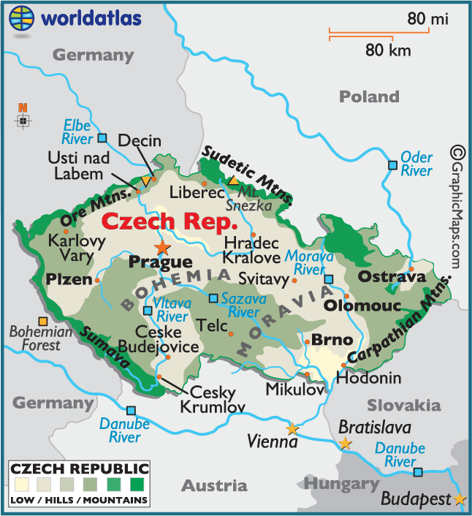 |  |  | 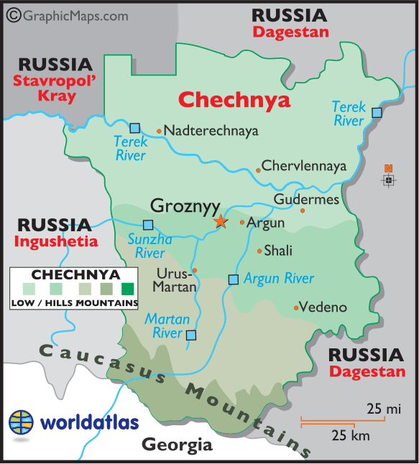
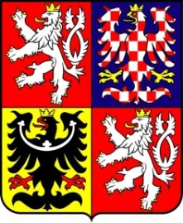 |  |  | 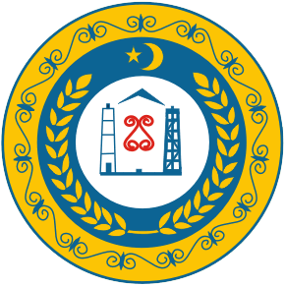
Česko je součástí Evropské unie a nachází se ve střední Evropě. Hlavním městem je Praha. Česko má asi 10,5 mil. obyvatel převážně nevyznávající žádné náboženství. Na území Česka žije zhruba 20 tis. Rusů.  wikipedia (česká mutace) |  |  | Čečensko je součástí Ruské federace a nachází se na severním Kavkaze v nejjižnější části východní Evropy. Hlavním městem je Groznyj. Čečensko má asi 1,3 mil. obyvatel vyznávajících převážně sunitský islám. Na území Čečenska žije zhruba 26 tis. Rusů.  wikipedia (anglická mutace)
Česká republika: spotřeba vybraných druhů potravin a osevní plocha máku
Spotřeba alkoholu (litry na obyvatele a rok) a osevní plocha máku (tis. ha) |  | Spotřeba vepřového a hovězího masa (kg na obyvatele a rok)

Ačkoliv některé hlavy států považují za projev existence islámu na státním území extremismus přerůstající v teroristické útoky:
„Netvrdím, že všichni muslimové jsou teroristé, tvrdím, že všichni teroristé jsou muslimové.“
(Reflex, 4. srpna 2011)
„Já řekl, že islám je náboženstvím nenávisti. A za tím si stojím, protože tento můj výrok nevyplynul z žádného předsudku, ale ze studia islámských textů.“
(Haló noviny, 10. ledna 2013)
„Nevěřím, že jsou umírnění muslimové a radikální muslimové. Stejně jako nevěřím, že jsou jen umírnění a radikální komunisté. Jsou jen muslimové a komunisté.“
(Mladá fronta Dnes, 28. června 2011)
V určité nadsázce lze za prvotní projev výskytu islámu na území jakéhokoliv státu považovat stánky s nápisem Döner Kebab, stejně jako to v českých pohádkách býval obchodních s tureckým medem.
Islám je však kulturní fenomén a záležitost vyznání, a proto druhotným projevem přítomnosti islámu jsou muslimské náboženské stánky a stavby: mešity, džamije a minarety.
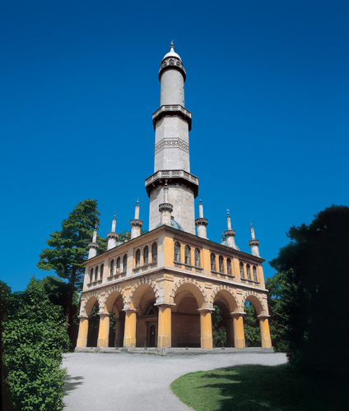
Po dlouhou dobu byl jedinou takovou stavbou minaret vybudovaný v letech 1797-1802 jako rozhledna ve Valticko-lednickém areálu z popudu Aloise I. Z Lichtenštejna. Po vzniku Ústředí muslimských náboženských obcí v roce 1991 a zejména pak registraci spolku u ministerstva vnitra v roce 2004 se situace změnila. Dnes existuje sedm mešit a 14 modliteben, přičemž žádná ze staveb není vybavena minaretem.
Letos 17. září uplynula desetiletá zkušební lhůta od registrace českých muslimů a jejich náboženské obce, po jejíž uplynutí lze požádat o vyšší stupeň registrace spojený s přiznání podobných práv, jako mají i ostatní církve v České republice. Pro jejich přiznání třeba, aby se k danému náboženství hlásilo alespoň jedno promile obyvatelstva, tedy asi 10 400 lidí. Podle sčítání lidu z roku 2011 se muslimskému vyznání hlásilo 3 358 osob.

III Islám a terorismus

Terrorist attacks mapped around the world
The Economist: Dec 4th 2012, 15:30 by Economist.com
OF THE 158 countries the Institute for Economics and Peace (IEP) cover in their inaugural global terrorism index, only 31 have had no attacks in the ten years to 2011. Yet although attacks are distributed widely around the world, the majority are concentrated in just a handful of countries. Iraq ranks first based on a five-year weighted average of the number of incidents, deaths, injuries and estimated property damage. It has suffered from the most attacks, including 11 of the world's worst 20. Indeed, Iraqis comprised one third of deaths from terrorism between 2002 and 2011. But while the number of incidents there have climbed since 2007, deaths have actually declined. Other terrorist hotspots include Pakistan, Afghanistan and India. The worst attack over the period was in Nepal, where 518 people died and 216 were injured. If there is any small cause for comfort, it is that terrorist incidents have plateaued since their peak in 2008.
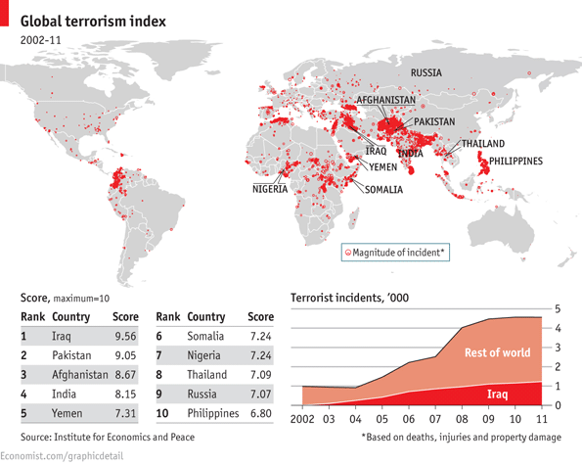

ISIL
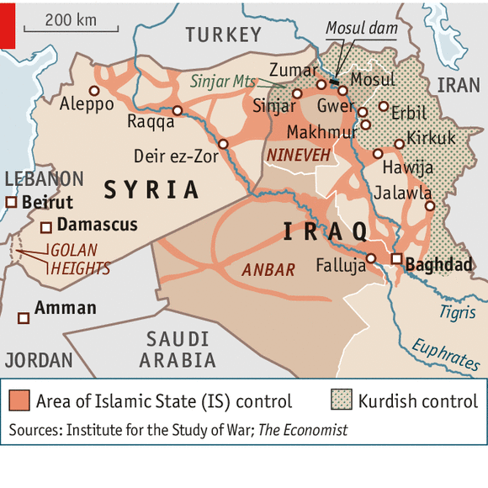 | 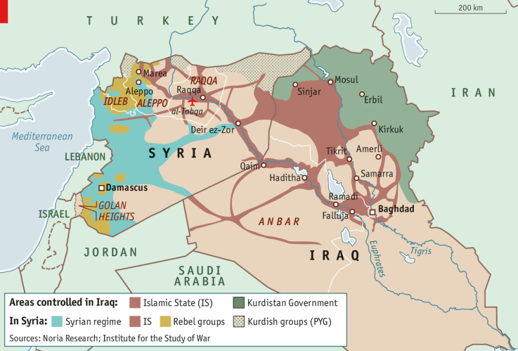
16. 8. 2014 | 23. 9. 2014
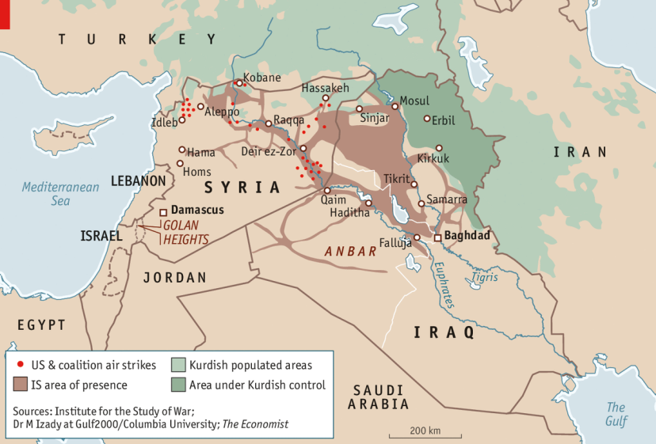 | 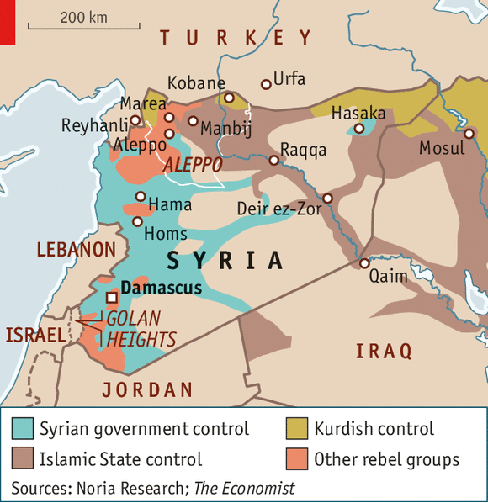
27. 9. 2014 | 4. 10. 2014

Stranger in a strange land
The Economist: Sep 2nd 2014, 13:42 by S.B., G.D. and P.K.
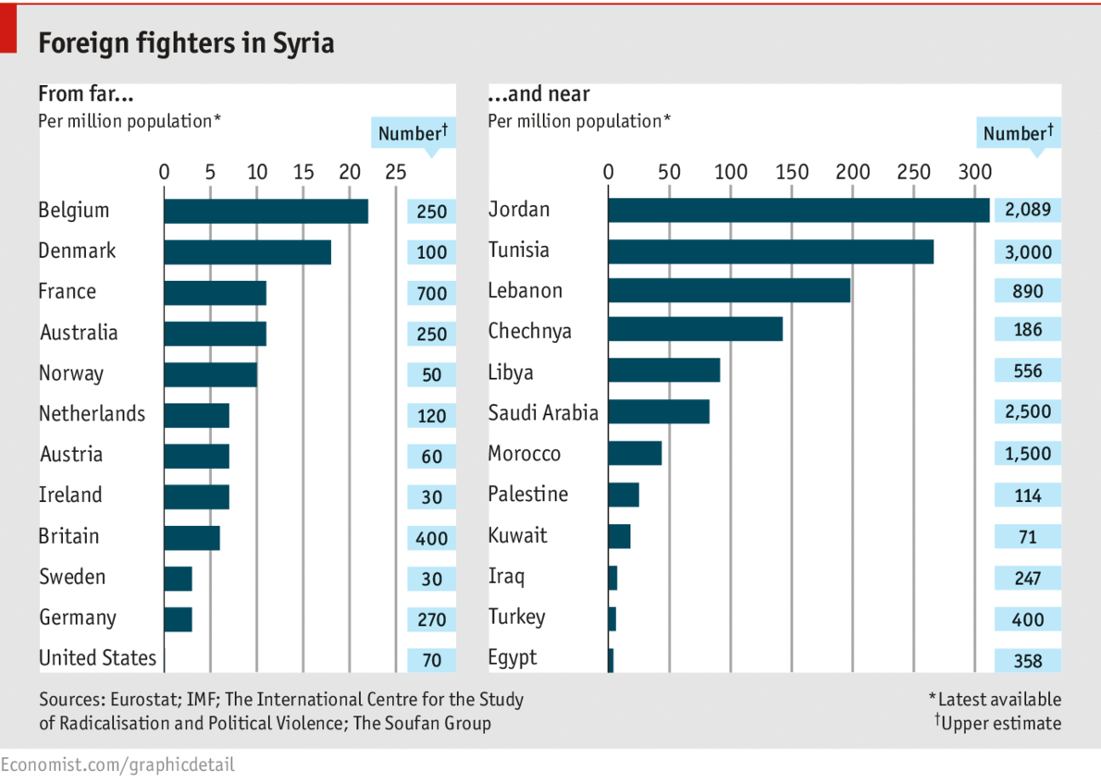
THE beheading of an American journalist last month by a jihadist with a noticeably British accent underscores the degree to which the civil war in Syria is attracting youths from abroad. Some are motivated to contribute to the creation of a caliphate, or Islamic state; others simply to escape drab lives at home. Yet why some countries are more represented than others is hard to explain.
Tunisians are estimated to be the largest contingent, possibly because domestic turmoil has weakened the security forces’ ability to track them. Yet those from Saudi Arabia and Jordan, with intrusive intelligence agencies, are almost as numerous. Those countries have a history of home-grown jihadism, yet ideology or a history of domestic extremism is not a full explanation. Iraqis, who comprise the leadership of the Islamic State, the militant group most foreign fighters join, make up relatively few foot soldiers.
In the West, more fighters hail from France than Britain, perhaps because it has a larger Muslim population. Belgium, which has experienced ethnic and religious tensions in recent years, tops the number of fighters per person partly owing to its relatively small population.
